Twitter APIs:

In this project phase 1, I used twitter APIs to search key word and find relevant tweets included images.

First of all, we need to create twitter developer account and receive twitter API credentials. And then we use api.search function to find the relevant tweets and print out the text of tweet as well as the url of images include in that tweet.

If we search puppy as our key word, we can get 3 tweets included images.

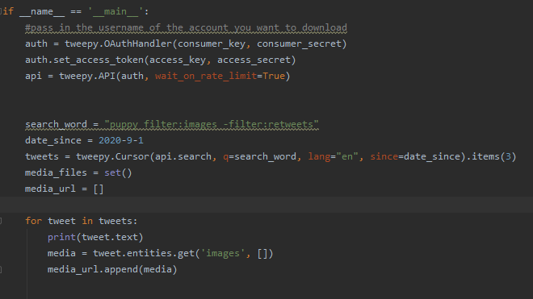

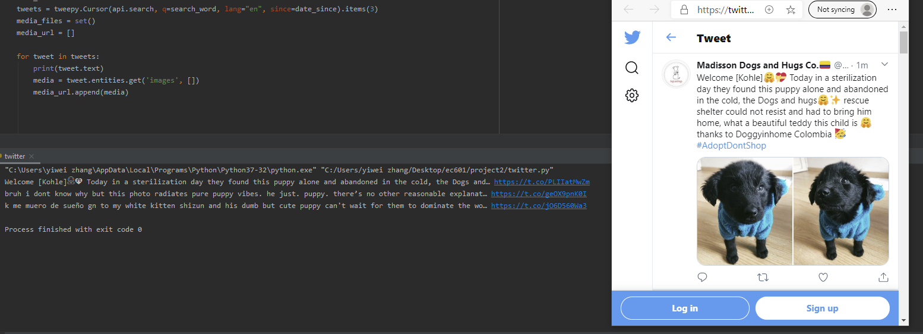

And we can get into twitter with the link provide.

Google NLP

In this project phase 1, I used google NLP to analyze the sentiment of text document and compare to the previous one to get emotion variation result. First of all, we need to create google NLP account and use the service account key file in your environment to find credential automatically.

If we type three different text document into our command, and it will return the score of each document and told us it becomes better or not compared to previous one.

